**Setting Up Chef-Workstation on windows**

##### **Step 1: Note your Internal DNS name and pem key of your Node**

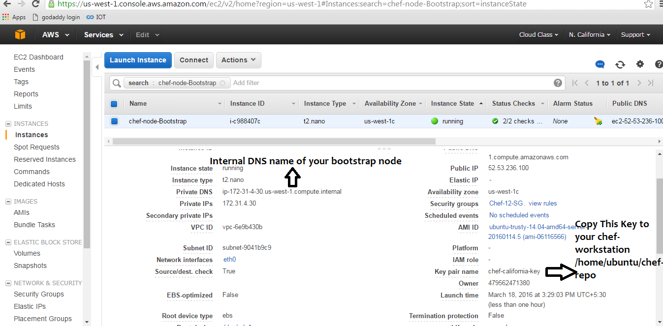

##### **Step 2 : Copy your pem file of Node which you intend to bootstrap**

Note : This should be copied on your chef-workstation

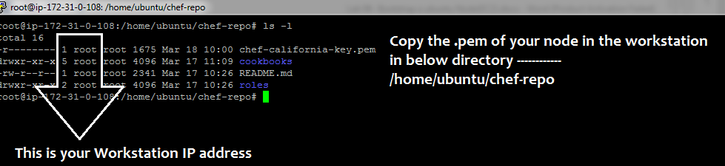

cp /home/ubuntu/chef-california-key.pem /home/ubuntu/chef-repo/

**Step 3 : Change permission to your pem file**

# chmod 400 chef-california-key.pem

**Step 4 : Bootstrap your first chef node**

knife bootstrap 54.197.20.223 -N node01 --ssh-user ubuntu --sudo --identity-file key.pem

##### knife node run_list set "node01" 'recipe[apache2]'

**Notes :**

* ip-172-31-4-30.us-west-1.compute.internal : This internal DNS name of your node
* --identify file : this is argument to supply .pem file of your node login

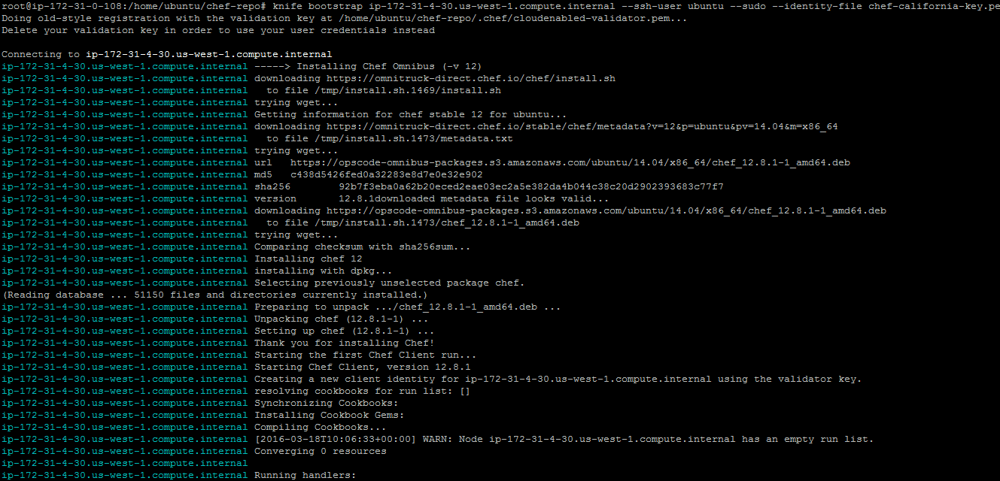

How boostrap works

It downloads a install.sh to your node and run it <https://omnitruck-direct.chef.io/chef/install.sh>

Lso downloads https://opscode-omnibus-packages.s3.amazonaws.com/ubuntu/14.04/x86_64/chef_12.8.1-1_amd64.deb

**Step 5 :** Apply the run list and run chef-client on Ubuntu server

knife ssh "*:*" -x ubuntu --identity-file ibm-public-key.pem "sudo chef-client"

Validate on web browser if your apache web is up and index.html is available

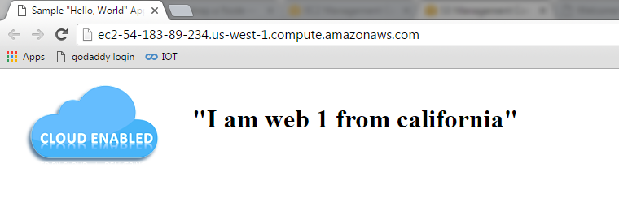

knife node show node01

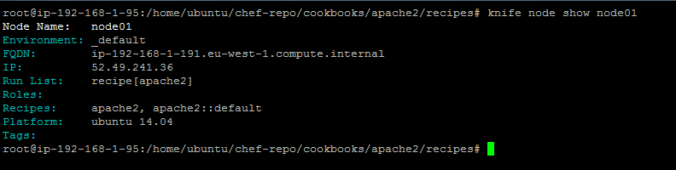

Bootstrap using username and password of node

knife bootstrap chefclient.itzgeek.local -x root -P pass --sudo

**Important options**:

**-x**: The ssh username

**-P**: The ssh password

**-p**: The ssh port

**-N**: Set your chef-client node name. Leaving this out will usually make hostname being used as the chef-client node name.

**–sudo**: If the user name on the node will need to use sudo to perform administrative actions, then use this flag. Note: It will prompt you for sudo the sudo password.